CPN 321 Part 3

The temperature control lab model refinement

**Group 8**

Alex Barrios

96011930

Stephani Crous

17014663

Phathutshedzo Maungo

14026963

Department of Chemical Engineering

University of Pretoria

South Africa

**Contents**

**1. Introduction 1**

**2. Parameter Estimation: Nonlinear Model 1**

**3. Parameter Estimation: Linear Model 5**

**4. Nonlinear vs Linear 6**

**5. Step Size 7**

**6. Linearity 8**

**7. Discussion 11**

# List of Figures

**Figure 1:** The model curve obtained before the model parameters were changed. 1

**Figure 2:** Results obtained when the TCLab is disconnected. 2

**Figure 3:** The response functions obtained for the model as well as for the TCLab. 2

**Figure 4:** Results obtained when the TCLab is connected. 3

**Figure 5:** The response functions obtained for the model as well as for the TCLab. 3

**Figure 6:** representation of the linear model. 6

**Figure 7:** The response obtained when the step size is decreased to 0.1. 7

**Figure 8:** The response obtained when the step size is increased to 2. 8

**Figure 9:** The gain obtained when the step input had a magnitude of 10. 9

**Figure 10:** The gain obtained when the step input had a magnitude of 50. 9

**Figure 11:** The gain obtained when the step input had a magnitude of 100. 10

**Figure 12:** Linearity test of the TCLab. 11

# List of Tables

**Table 1:** Original parameter values and the fitted parameter values. 4

**Table 2:** The differences between the linear and the nonlinear model. 6

**Table 3:** Different gains obtained when different step inputs were used. 10

The temperature control lab model refinement

# Introduction

In this part of the project, the process parameters, as defined in Part 1, were redefined in order to generate a model that better predicts the experimental data. A linear model was created and compared to the data being generated by the TCLab. The linear model was compared to the nonlinear model in order to determine the similarities as well as the differences between the two models. The step size ( was changed in order to determine the accuracy of the simulation. Lastly, the linearity of the model was investigated in order to determine if the model is linear or nonlinear.

# Parameter Estimation: Nonlinear Model

The first approximation for the parameters, was performed with the TCLab disconnected. It was executed in such a manner in order to determine which parameters influence the gain (as well as the time constant (. It was found that the heat capacity ( influences in a directly proportional manner. When is increased the time constant of the response is also faster. It was also found that the convective heat transfer coefficient ( influences in an inversely proportional manner. When is increased the gain of the response decreased. Figure 1 is an illustration of the model curve predicting the physical TCLab, before any changes were made to the model parameters.



**Figure 1:** The model curve obtained before the model parameters were changed.

Figure 2 is an illustration of the step input being made to Sensor 1, after changes to the parameters were made and the TCLab was disconnected. No step input was given to Sensor 2 in all the cases to follow.

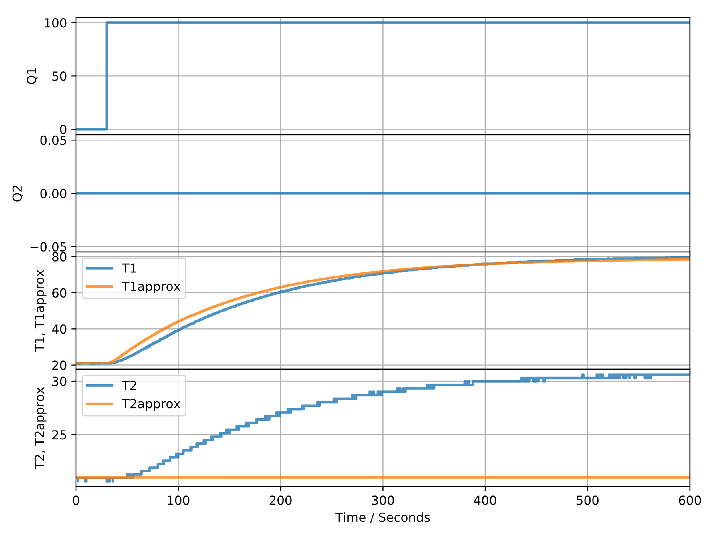

**Figure 2:** Results obtained when the TCLab is disconnected.

Figure 3 is an illustration of the response function of the model as well as that being created by the TCLab. Changes to the parameters were made and the TCLab was disconnected before running the simulation.

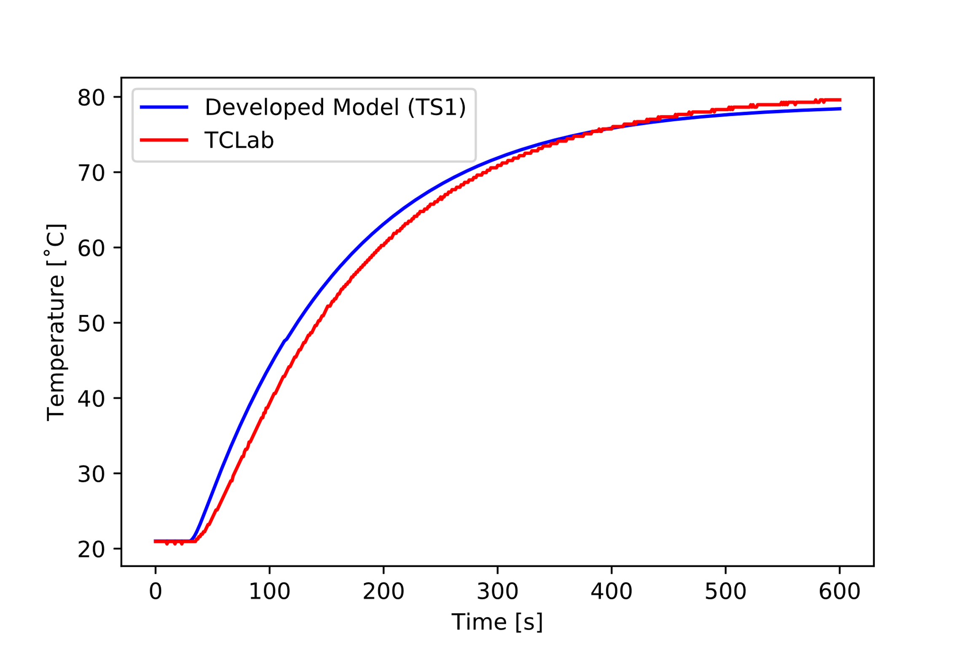

**Figure 3:** The response functions obtained for the model as well as for the TCLab.

After determining which parameters influence the time constant and the gain of the response, the TCLab was connected. Figure 4 is an illustration when a step input was given to Sensor 1. The changes to the parameters were made and the TCLab was connected. No step input was given to Sensor 2.

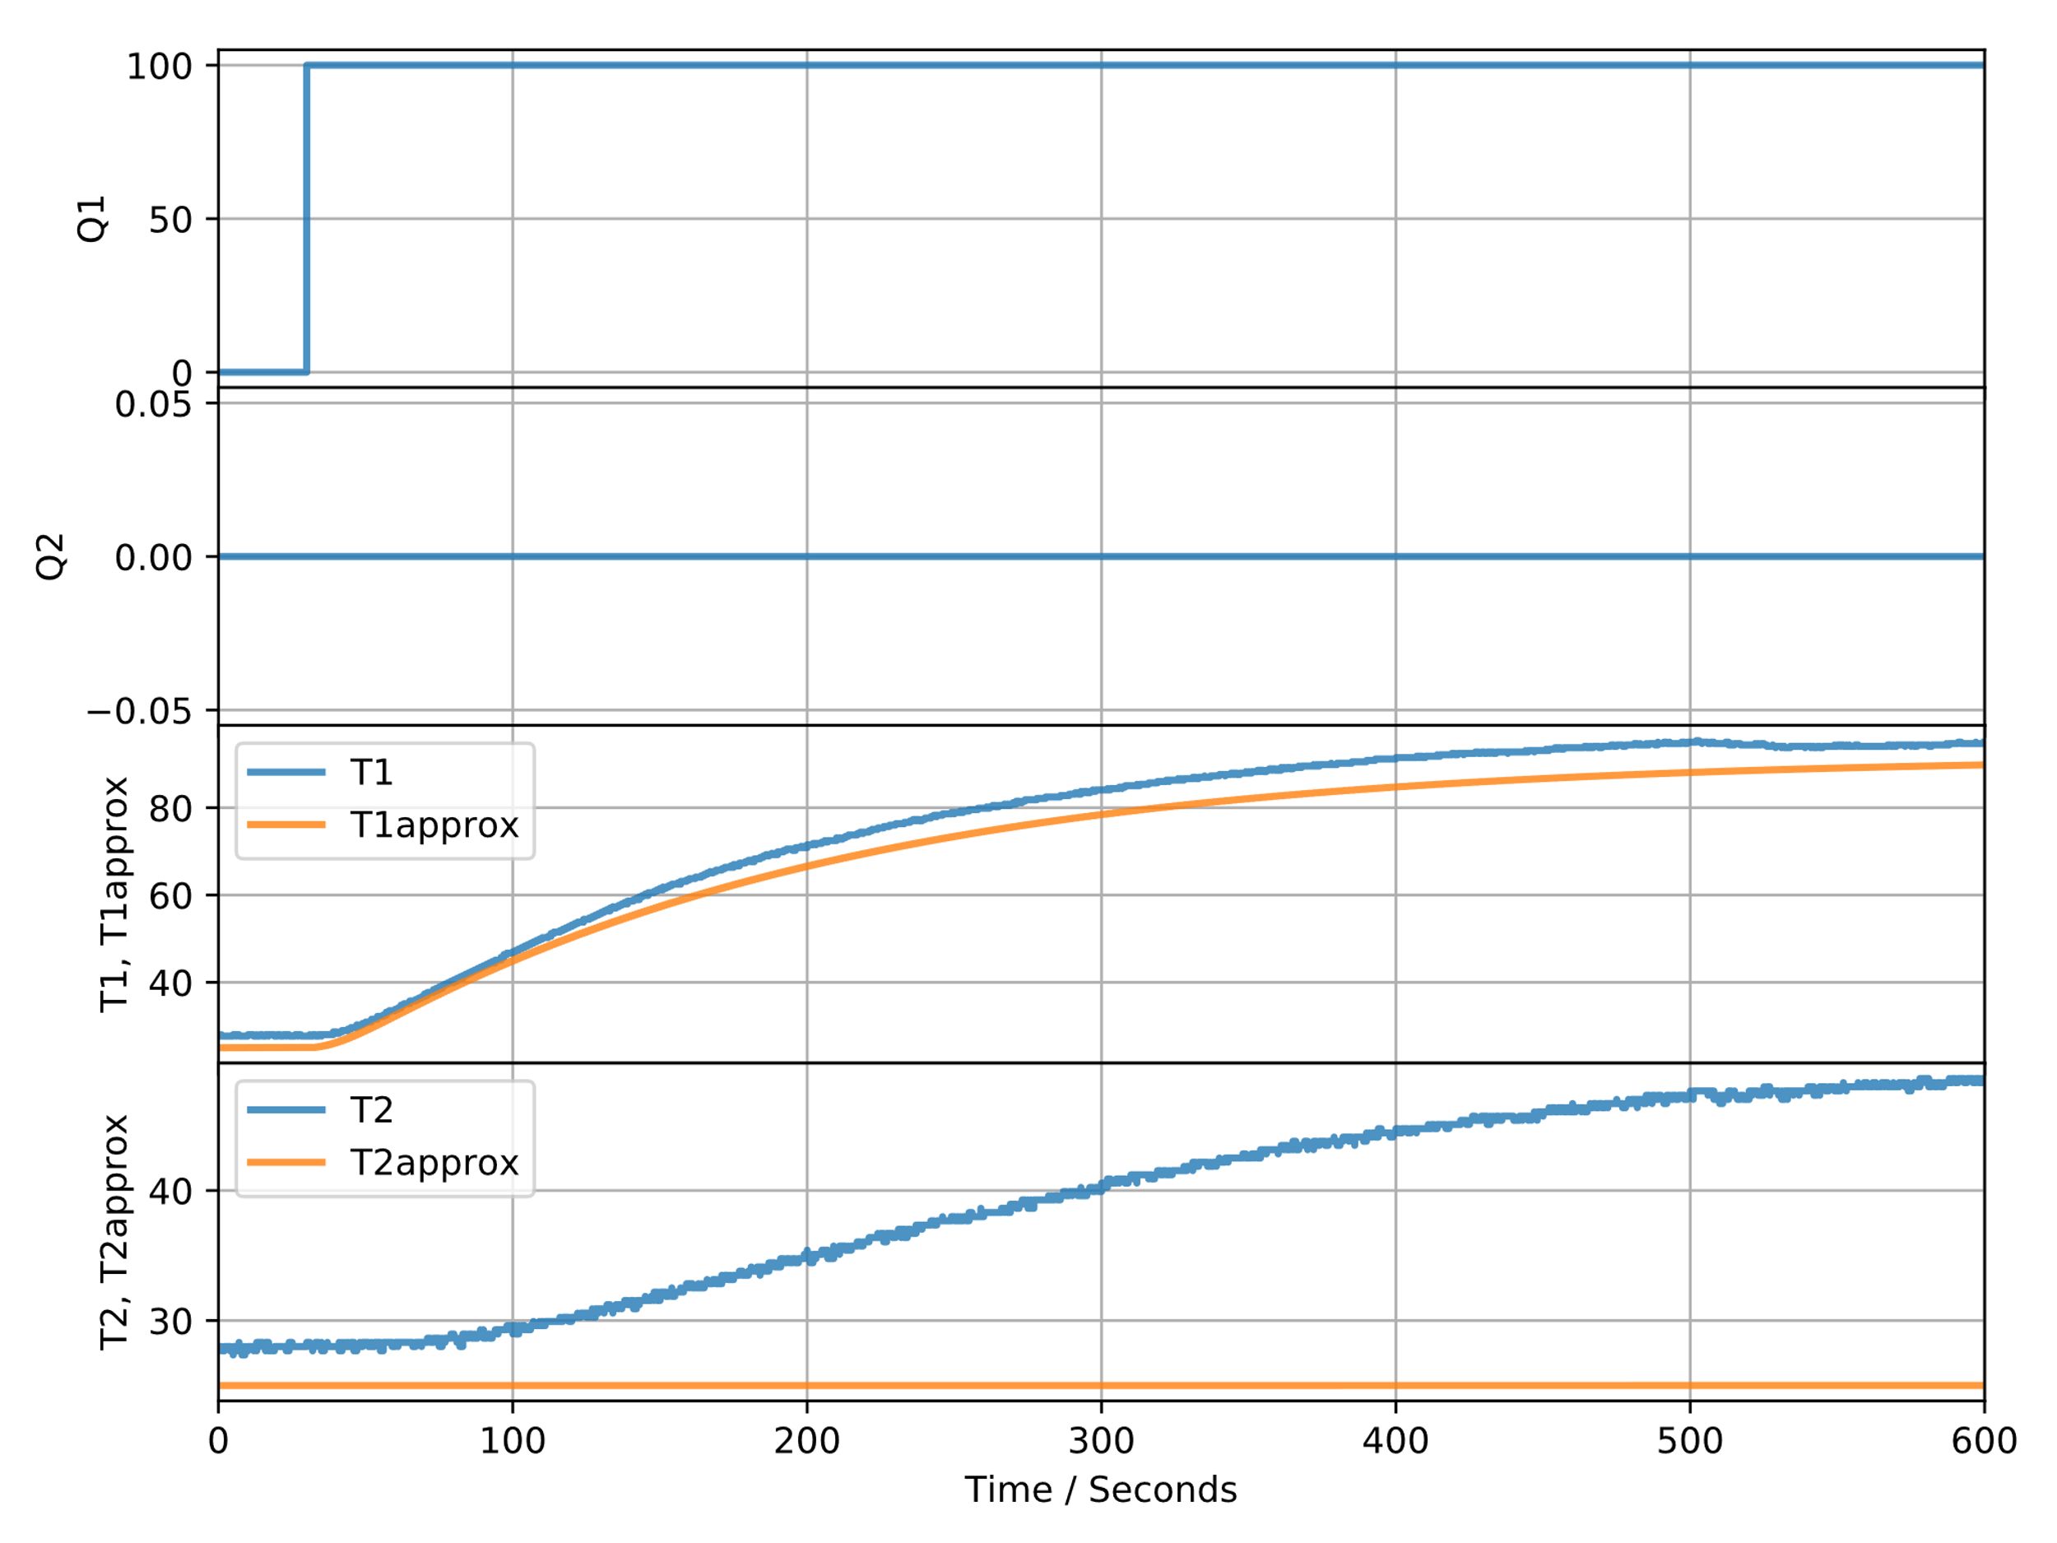

**Figure 4:** Results obtained when the TCLab is connected.

The gain of the two curves are close to one another. Figure 5 is an illustration of the response function, when changes to the parameters were made and the TCLab was connected.

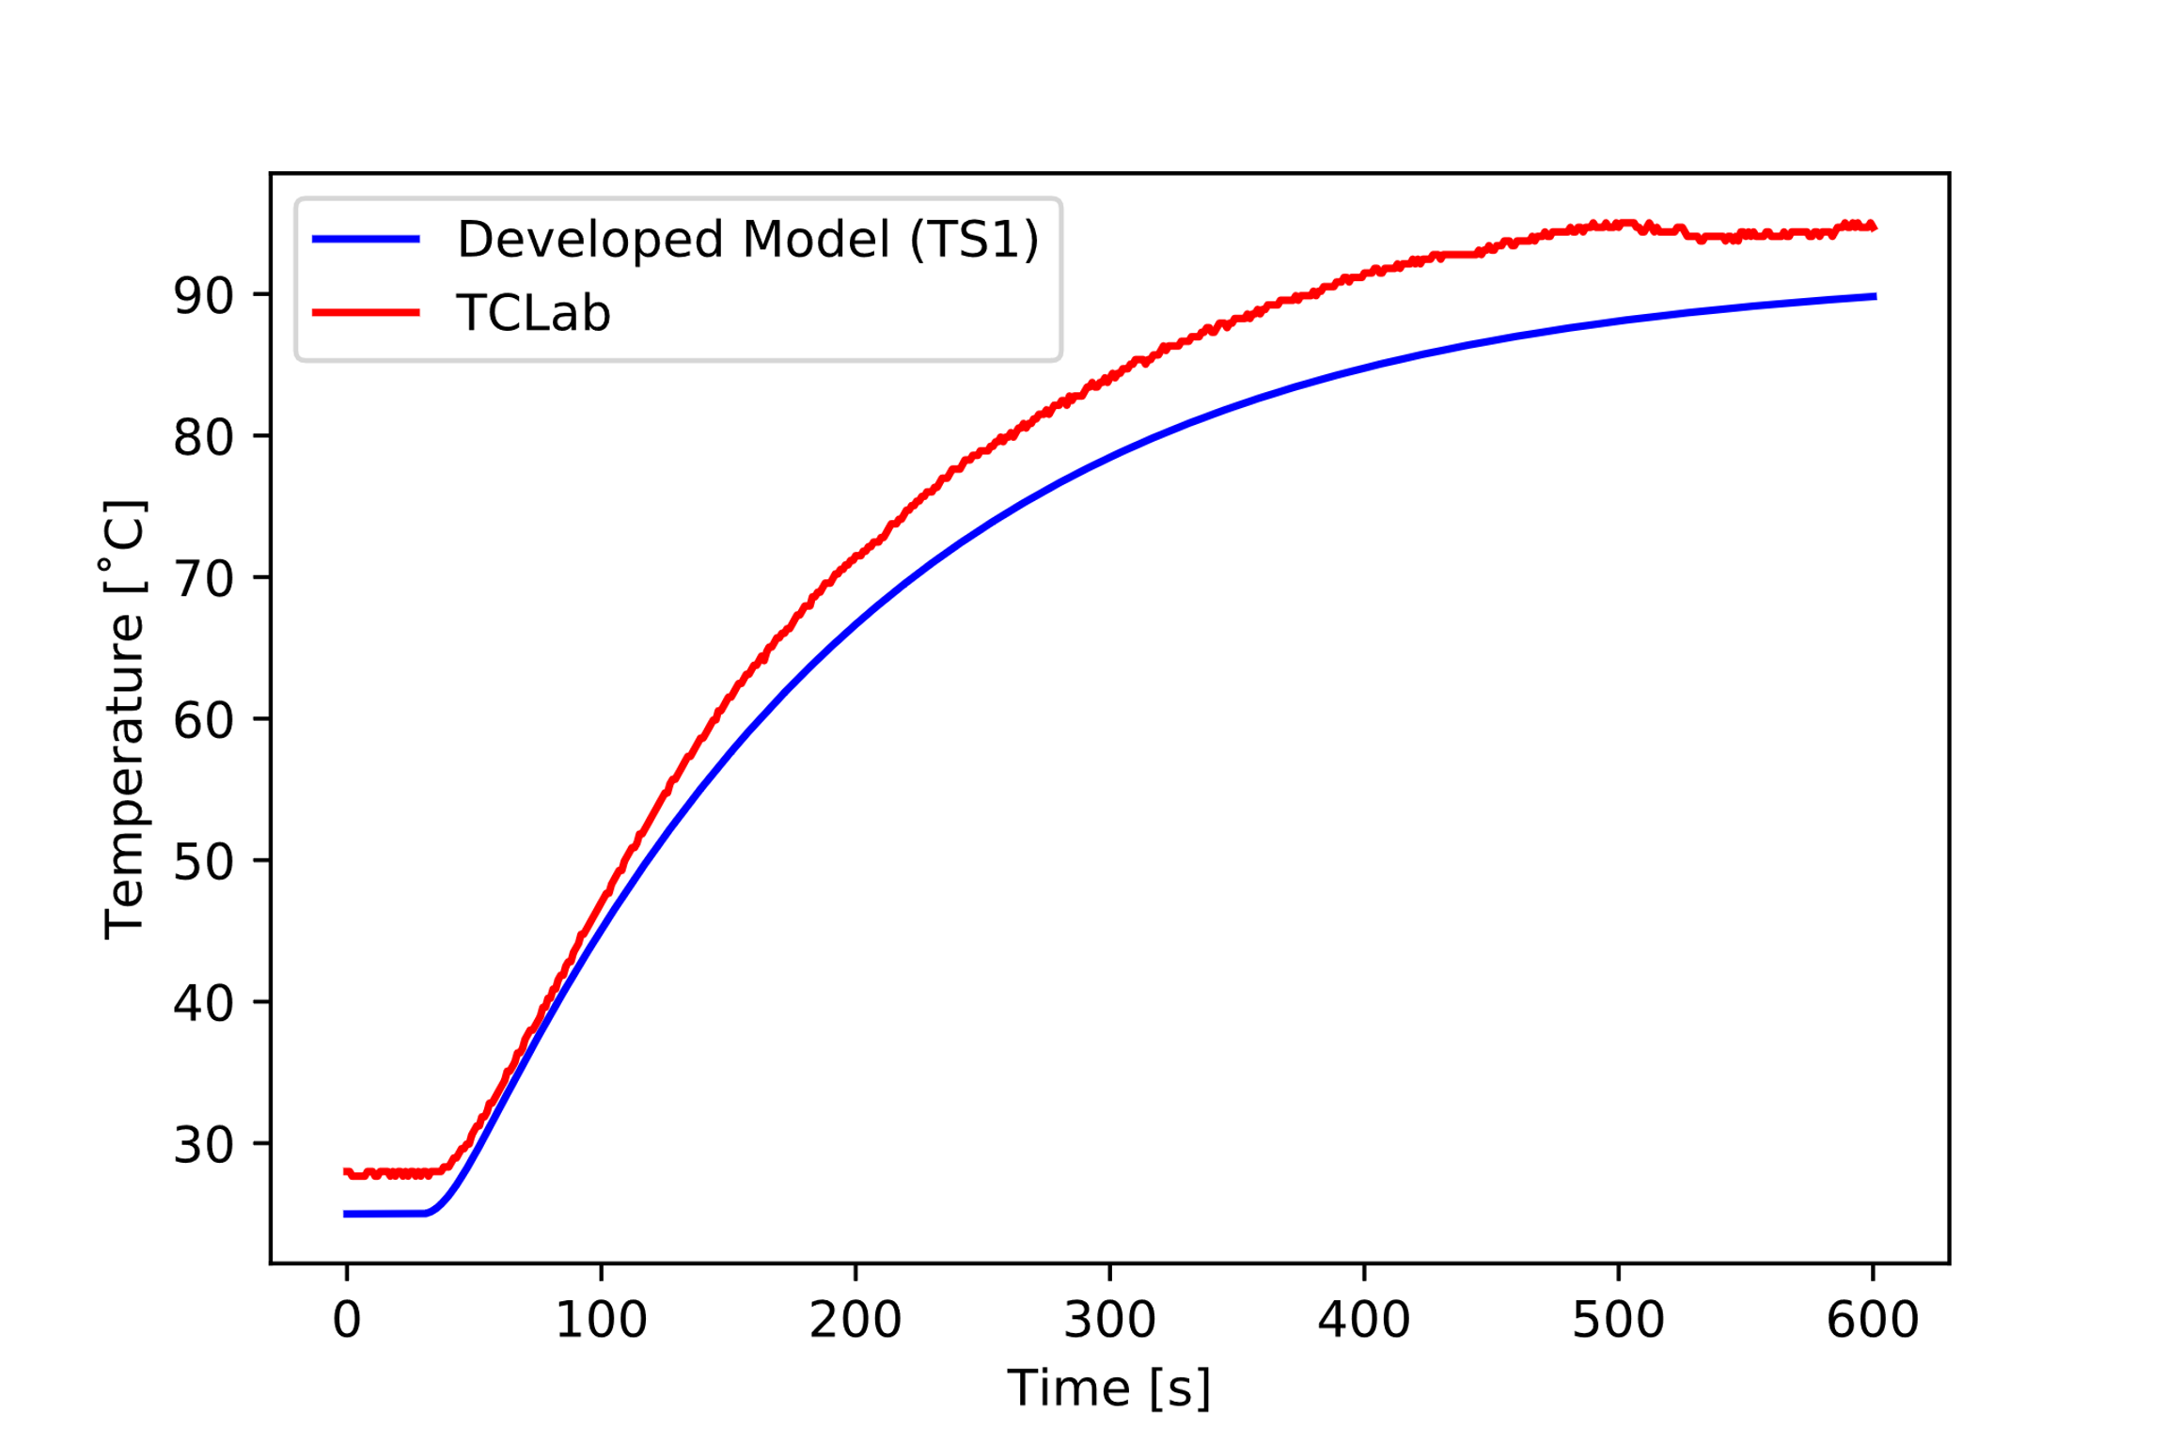

**Figure 5:** The response functions obtained for the model as well as for the TCLab.

Manual tuning was done to determine the new values for the parameters. After analysing Figure 4 and Figure 5, it was noted that the two curves approach the same gain. Figure 4 denotes that the time constant for the two curves are close to one another. Table 1 summarises the changes that were made to the original parameters, as defined and described in Part 1.

**Table 1:** Original parameter values and the fitted parameter values.

|  |  |  |  |  |
| --- | --- | --- | --- | --- |
| Symbol | Description | Units | Numeric Value | Fitted Value |
|  | Heat transfer coefficient of ambient air. | W m⁻² K⁻¹ | 10.45 | 8.88 |
|  | Area of fin bank 1. | m² | 4.00x10-4 | - |
|  | Temperature of ambient air. | K | 297.15 | 298.15 |
|  | Area of fin bank 2. | m² | 4.00x10-4 | - |
|  | Emissivity. | - | 0.85 | - |
|  | Stefan-Boltzmann constant. | W m⁻² K⁻⁴ |  | - |
|  | Side area of fins on fin bank 1. | m² | 9.00x10-5 | - |
|  | Side area of fins on fin bank 2. | m² | 9.00x10-5 | - |
|  | Mass of fin bank 1. | kg | 2.90x10-3 | 1.89x10-3 |
|  | Heat capacity of fin bank 1. | J kg⁻¹ K⁻¹ | 502.42 | 326.57 |
|  | Mass of fin bank 2. | kg | 2.90x10-3 | 1.89x10-3 |
|  | Heat capacity of fin bank 2. | J kg⁻¹ K⁻¹ | 502.42 | 326.57 |
|  | Density of fin bank 1. | kg m⁻³ | 7900.00 | - |
|  | Density of fin bank 2. | kg m⁻³ | 7900.00 | - |
|  | Volume of fin bank 1. | m³ | 3.60x10-4 | - |
|  | Volume of fin bank 2. | m³ | 3.60x10-4 | - |
|  | Area of heater 2. | m² | 8.00x10-5 | - |
|  | Path length that heat travels in heater 2. | m | 1.50x10-3 | - |
|  | Heat transfer coefficient of heater 1. | W m⁻² K⁻¹ | 10.45 | 8.88 |
|  | Heat transfer coefficient of heater 2. | W m⁻² K⁻¹ | 10.45 | 8.88 |
|  | Mass of heater 1. | kg | 1.90x10-4 | 1.24x10-4 |
|  | Heat capacity of heater 1. | J kg⁻¹ K⁻¹ | 502.42 | 326.57 |
|  |  |  |  |  |
| Symbol | Description | Units | Numeric Value | Fitted Value |
|  | Mass of heater 2. | kg | 1.90x10-4 | 1.24x10-4 |
|  | Heat capacity of heater 2. | J kg⁻¹ K⁻¹ | 502.42 | 326.57 |
|  | Heat factor of heater 1. | W | 0.01 | - |
|  | Heat factor of heater 2. | W | 7.50x10-3 | - |
|  | Heat transfer coefficient of sensor 1. | W m⁻² K⁻¹ | 10.45 | 8.88 |
|  | Area of sensor 1. | m² | 1.60x10-5 | - |
|  | Heat transfer coefficient of sensor 2. | W m⁻² K⁻¹ | 10.45 | 8.88 |
|  | Area of sensor 2. | m² | 1.60x10-5 | - |
|  | Mass of sensor 1. | kg | 2.50x10-4 | 1.63x10-4 |
|  | Heat capacity of sensor 1. | J kg⁻¹ K⁻¹ | 502.42 | 326.57 |
|  | Mass of sensor 2. | kg | 2.50x10-4 | 1.63x10-4 |
|  | Heat capacity of sensor 2. | J kg⁻¹ K⁻¹ | 502.42 | 326.57 |

The heat capacity was multiplied by a factor of 0.85. The convective heat transfer coefficient as well as the mass of each component (sensors, heaters and fins) were multiplied by a factor of 0.65. These parameters were used in order to obtain the graph presented in Figure 5. The factors were chosen in such a manner that the values of the heat capacity, convective heat transfer coefficient and the mass of the units were still reasonable and within a realistic range.

# Parameter Estimation: Linear Model

State space analysis was used in to create the linear model. Figure 6 is an illustration of the responses obtained after the linear model was used to approximate the TCLab unit.

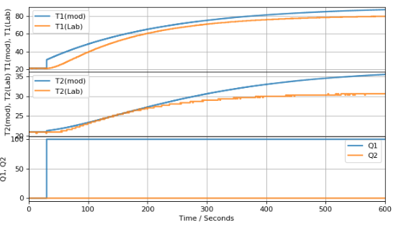

**Figure 6:** representation of the linear model.

The temperature curve created, for sensor 1, by the linear model is a good approximation of the TCLab unit, because the gains of the two curves are close to one another. Noise was experienced and caused the curves to be rough instead of smooth. Only a step input was given to sensor 1. No step input was given to sensor 2. The difference between the gains for sensor 1 is smaller than that of sensor 2. When the step input was implemented, it caused a peek in the response of sensor 1.

# Nonlinear vs Linear

The nonlinear and linear models were compared with one another, in order to determine which model will be the best option to use, if the behaviour of the TCLab unit were to be modelled. Table 2 summarises the differences between the nonlinear and the linear model.

**Table 2:** The differences between the linear and the nonlinear model.

|  |  |
| --- | --- |
| Nonlinear model | Linear model |
| The response, after the step input was applied, closely approximate the TCLab model. | A step occurs at the location where the TCLab model tends to a second order response. |
| The difference between the gains is less. | The difference between the gains is more. |
| A larger gain is achieved. | A lower gain is achieved. |

After taking the differences, as summarised in Table 2 into consideration, it was noted that the nonlinear model is more accurate than the linear model. Thus, the nonlinear model has better predictive capability.

# Step Size

The effect of changing the step size, used in the Euler integration, was examined. The following effects were focussed on:

* When the step size is increase to 2.
* When the step size is decreased to 0.1.

Figure 7 is an illustration of the response obtained when the step size is decreased to 0.1.

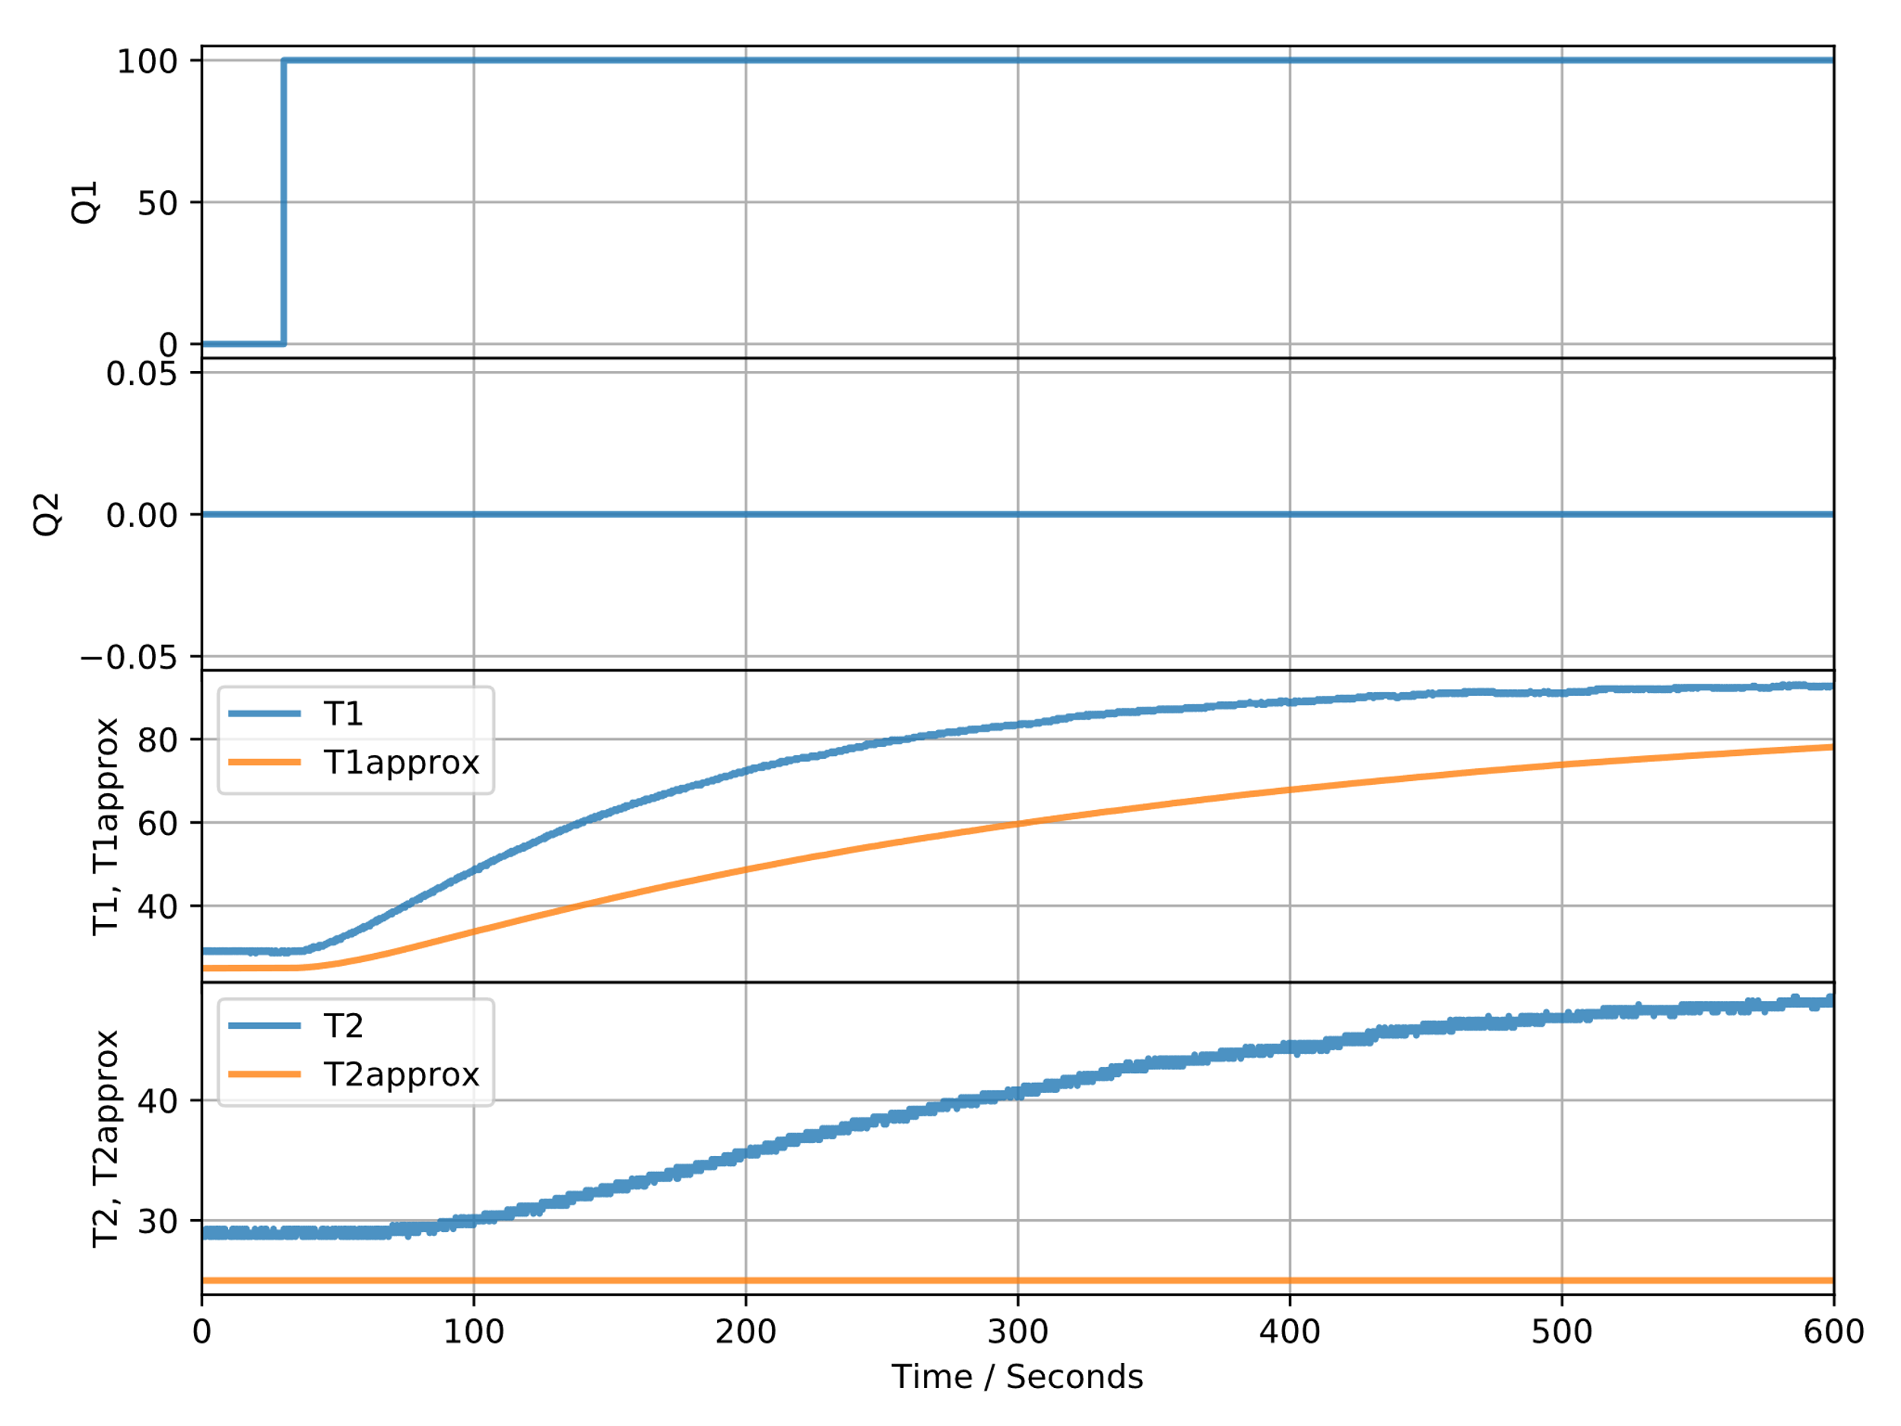

**Figure 7:** The response obtained when the step size is decreased to 0.1.

When the step size is decreased to a very small value, more strain is placed on the CPU in order to process the data and calculate the desired results. The accuracy, between the model curve and the curve produced by the TCLab, are less, when compared to the accuracy between the two curves presented in Figure 2. In Figure 7 it can be observed that the model takes longer in order to reach the desired gain. Thus, the response is slower. The time to run the simulation also took longer when compared to the rest of the simulations. Figure 8 is an illustration of the results obtained when the step size is increased to 2.

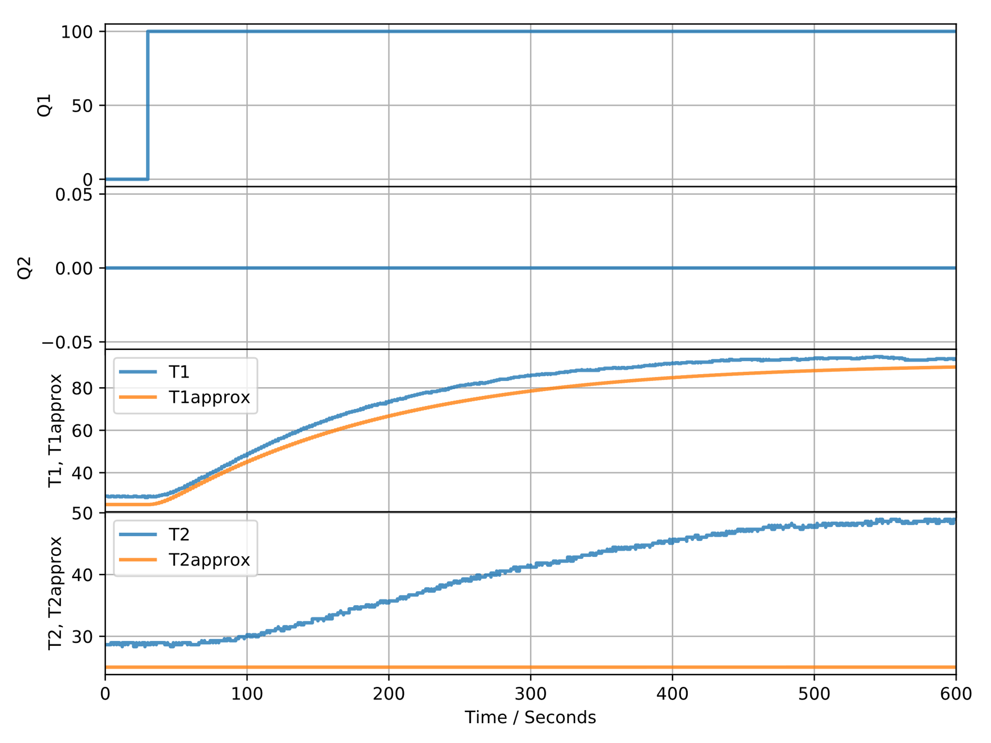

**Figure 8:** The response obtained when the step size is increased to 2.

When increasing the step size, it can be denoted that the accuracy between the two curves increases. When comparing Figure 8 to Figure 2, it is difficult to distinguish between the two results. The blue curves in the above figure do not have smooth curves, illustrating noise in the response. When increasing the step sizes even more, the possibility arises that the integral may not converge.

After comparing Figure 7 and Figure 8, it can be observed when increasing the step size used in the Euler integration, it increases the accuracy between the model prediction and the real TCLab. The accuracy in predicting the real TCLab decrease, when the step size is decreased.

# Linearity

The linearity of the TCLab unit was evaluated. In order to determine if the TCLab is linear or nonlinear, the gains obtained when the magnitude of the step inputs were varied, were evaluated. Three different step inputs, each with a different magnitude, were evaluated. The three step changes are: 0–10; 0–50; and 0–100. Figure 9 is an illustration of the gain obtained when the step input had a magnitude of 10.

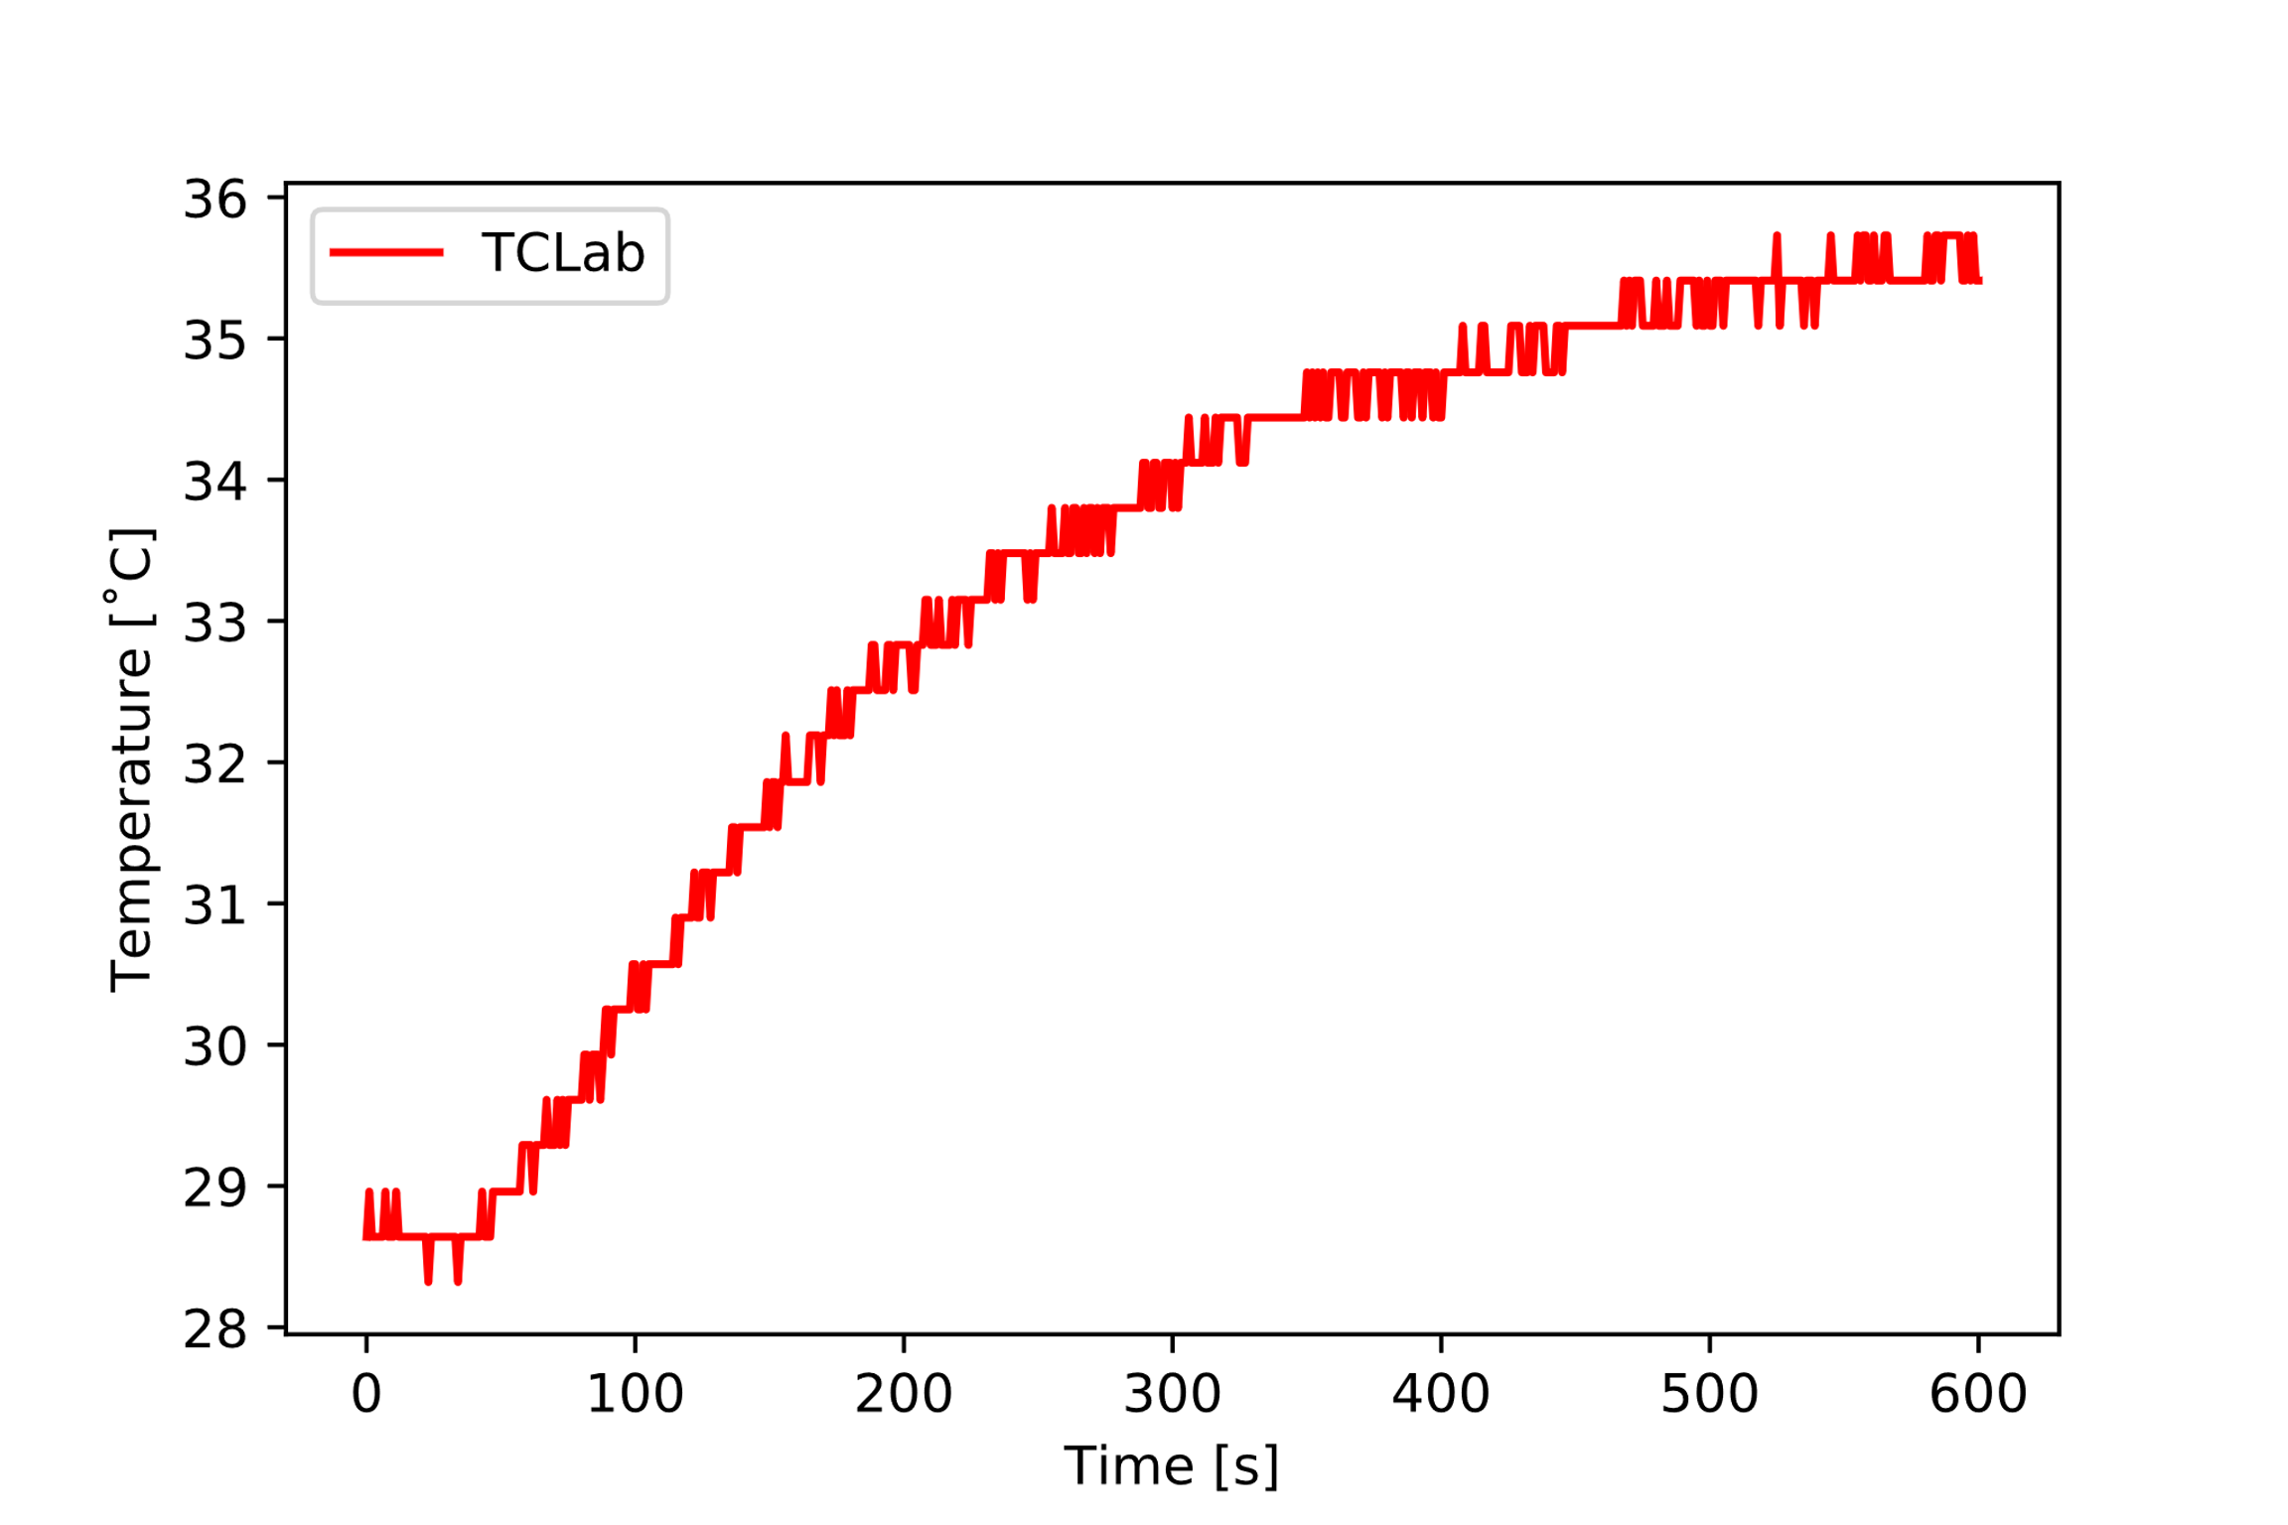

**Figure 9:** The gain obtained when the step input had a magnitude of 10.

Figure 10 is an illustration of the gain obtained when the step input had a magnitude of 50.

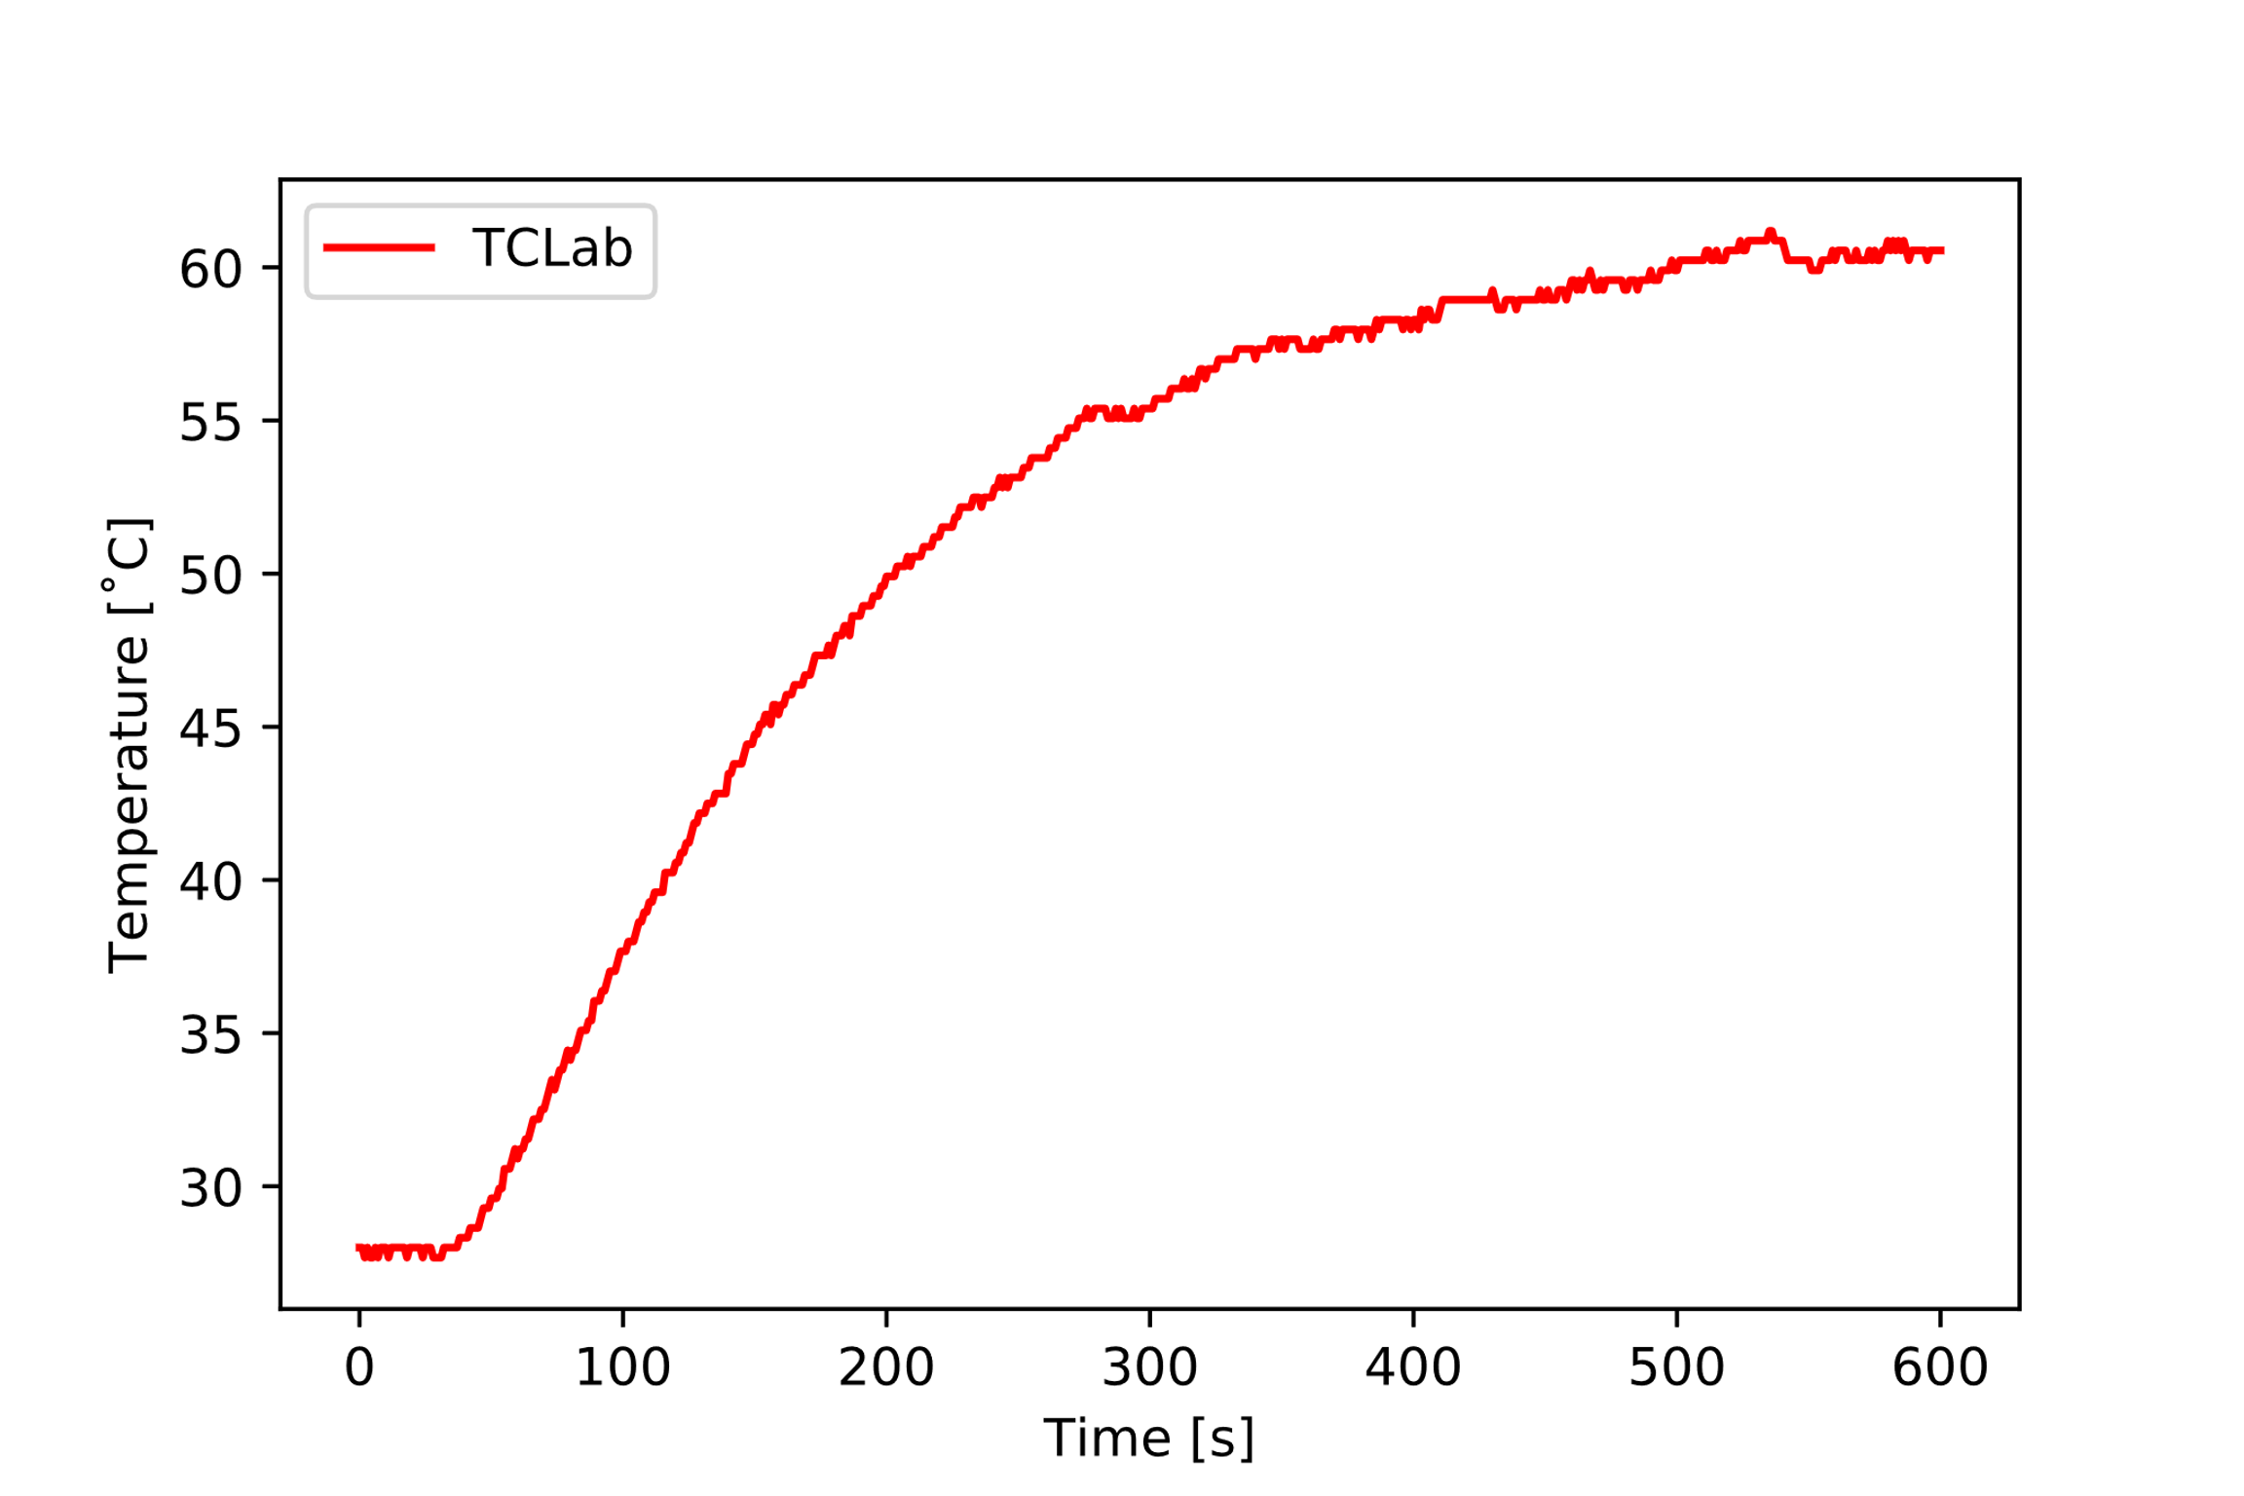

**Figure 10:** The gain obtained when the step input had a magnitude of 50.

Figure 11 is an illustration of the gain obtained when the step input had a magnitude of 100.

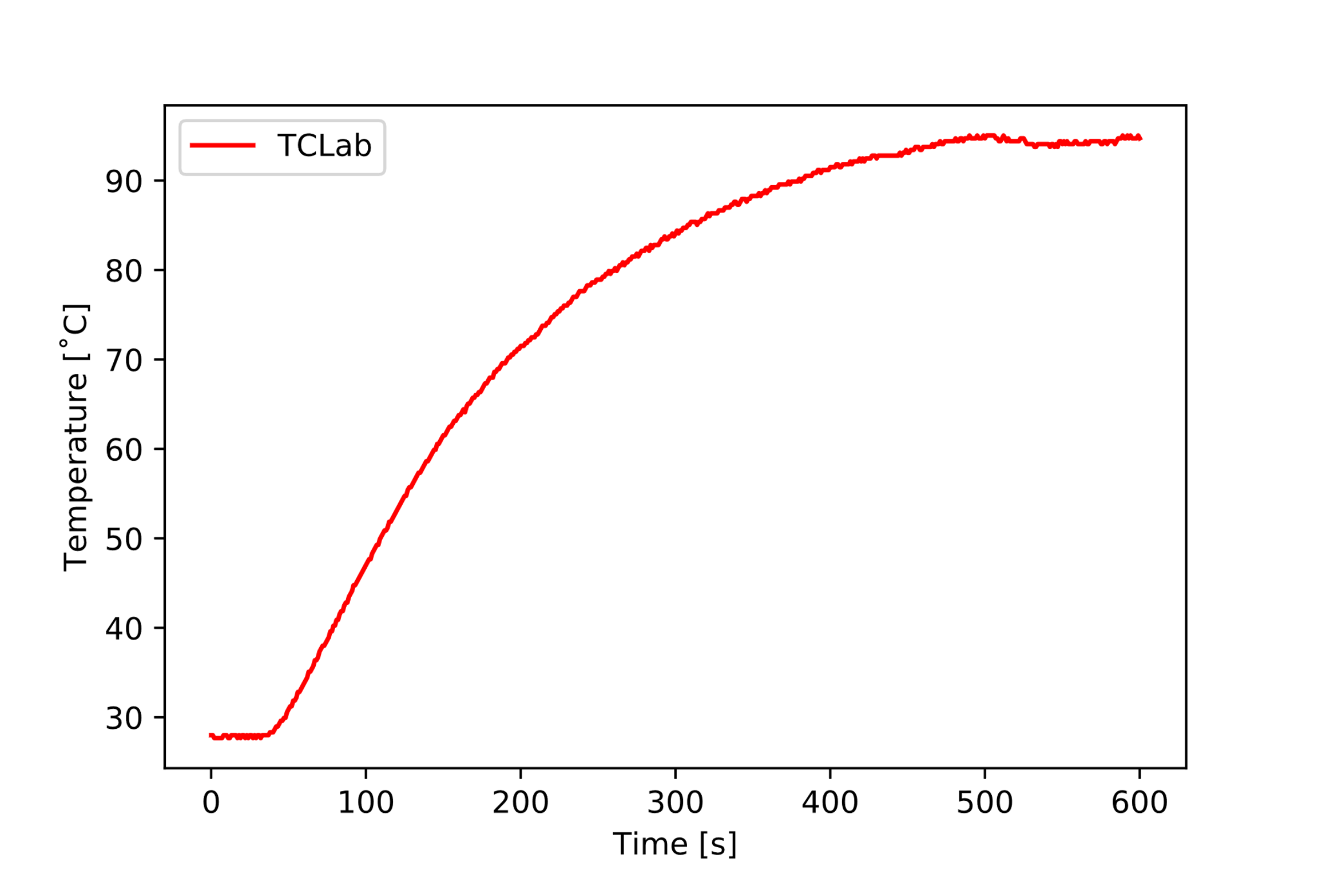

**Figure 11:** The gain obtained when the step input had a magnitude of 100.

A linear system is a system that will obtain the same gain, no matter what the magnitude of the step input is. This statement was evaluated by plotting the gains for the different step inputs. Table 3 summarises the gains obtained when different step inputs were used.

**Table 3:** Different gains obtained when different step inputs were used.

|  |  |
| --- | --- |
| Step input | Gain (  (ºC/%) |
| 0–10 | 0.68 |
| 0–50 | 0.65 |
| 0–100 | 0.67 |

The different gains were plotted on the same graph in order to determine whether the TCLab unit resembles a linear or a nonlinear system. Figure 12 illustrates the different gains obtained for the different step sizes used.

**Figure 12:** Linearity test of the TCLab.

After evaluating Figure 12 it can be concluded that the TCLab unit resembles the behaviour of a nonlinear system, because the gains obtained for different magnitudes of step inputs are different. The only nonlinear term in the model equations is the radiation term. The final temperature being achieved is a function of the nonlinear term. Thus, the final temperature is also nonlinear.

# Discussion

After evaluating the prediction accuracy between the real TCLab model with nonlinear model and the linear model, it was noted that the nonlinear model presented more accurate results. The model parameters were changed in such a manner that the nonlinear model provides a good approximation to the real system. The parameters were changed in such a manner that they still fall within a range of values that will result in reliable predictions. The two curves presented in Figure 2 tend to the same gain. is also quite similar for the two curves.

Changing the magnitude of the step inputs resulted in different gains. After representing the data graphically, it was noted that the actual TCLab unit does not follow the trend for a linear system. The TCLab unit follows nonlinear behaviour.